Russell Ng M19403 CS4132 Project Report

Considering a range of developmental indicators such as GDP per capita (PPP) (Fig. 0.1a, 0.1b), life expectancy (Fig. 0.2a, 0.2b) and number of mobile subscriptions per 100 people (Fig. 0.3a, 0.3b), we see that Singapore is a highly developed country which ranks in the top few countries globally, and considering this trend is projected to continue increasing, not just for Singapore, but also for the world (including already developed countries) (Fig. 0.4a, 0.4b, 0.4c), it remains to investigate the current sustainability of such development, as well as measures for future sustainable development.

In this project, by considering several indicators representative of the 17 Sustainable Development Goals (SDGs) as outlined by the United Nations, as well as Singapore-specific data, we aim to investigate Singapore’s progress towards achieving certain SDGs, and by comparing Singapore with other nations, to investigate possible solutions in other countries that may be relevant in Singapore. In particular, we focus on countries with similar developmental status as Singapore, such as: the US, Japan, Korea, the UK, France, Germany, Norway, Denmark, Sweden, Finland, and Australia, as well as the BRIC nations (rapidly developing countries): Brazil, Russia, India, China. We also look at specific goals that Singapore has set (in accordance with the Kyoto Protocol and Paris agreement), whether we are on track to meet these goals, and possible areas we may focus on in the future).

The datasets used are taken from the following organizations/websites (URLs in appendix):

World Bank, OurWorldInData, Kaggle, Gapminder, United Nations Development Programme

Results & Findings:

The format of the data is a time series, which we firstly plot (both as a line graph and boxplot) and generate a 5-number summary of. Afterwards, we split the indicators (35) into two kinds, sustainability (15) and development (20). We then narrow the country to Singapore, and for each sustainability indicator, we determine its coefficient of correlation (R) with the development indicators and plot it as a heatmap. This allows us to visualise which development indicators are correlated to unsustainable development. The combined heatmaps are shown here (y axes are sustainability indicators, and x axes (except 0) are development indicators) (Fig. 1.1a):

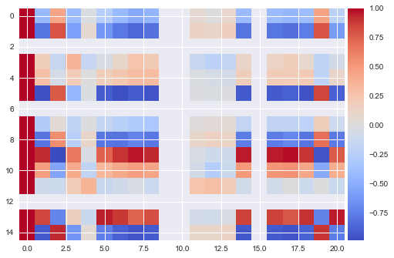

We then compare the above correlation heatmap with the expected correlations (ie. For CO2, we expect that for sustainable development, as GDP per capita increases, CO2 emissions should decrease, this is a negative correlation, thus if the observed correlation is negative, then the correlation is in the correct direction and is assigned a value of 1, if the correlation is in the opposite direction, a score of -1, and if the magnitude of correlation is very small (<= 0.1), a score of 0. Nans are left blank by default). The combined scored correlation heatmap are shown below (Fig. 1.1b):

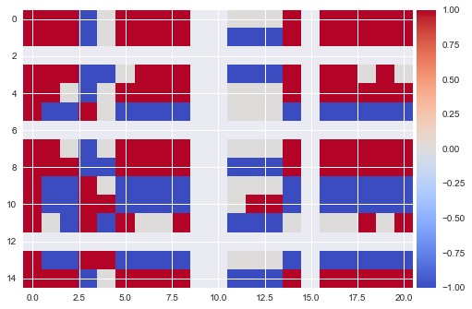

In addition, due to the possibility that the sustainability and development indicators were not linearly related, we then calculated the Spearman rank order correlation of the indicators to visualise how the indicators vary with each other (Fig. 1.2a):

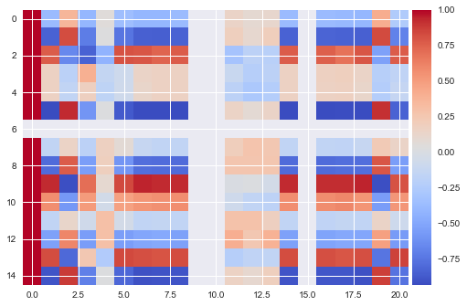

Again, we then compare these values with the expected correlations and generate scores (Fig. 1.2b):

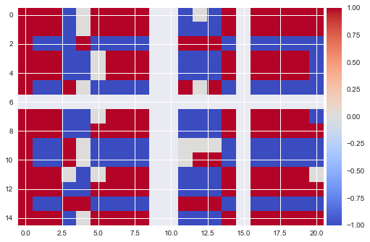

Based on the heatmaps, we conclude that the areas of greatest improvement for Singapore are

[Indicator name, unit (number of unsustainable indicators)]:

Greenhouse gas emissions, kt (13/20)

Forest area, % (12/20)

Electrical power consumption per capita, kWh (12/20)

Oil consumption per capita, tonnes (12/20)

Annual mean temperature, degC (12/20)

The criteria for deciding if an indicator requires significant improvement is if it has >9/20 unsustainable indicators. Based on this, the most sustainably developed country (amongst those analysed) would be Denmark (Fig. 1.3a,b) and Sweden (Fig. 1.4a,b), with just 1 such indicator each, Annual Mean Temperature. Besides these, we also compare Singapore with other developing nations such as China (Fig. 1.5a,b) and India (Fig. 1.6a,b), and observe that these nations are developing in an extremely unsustainable manner.

For greenhouse gas emissions, due to missing data in the earlier half of the timeframe of the data (1991-2012), it is difficult to accurately say whether greenhouse gas emissions are an unsustainable indicator, especially since many of the correlation values, while non-negligible, are still around a magnitude of 0.25, representing a rather weak correlation. It is interesting, however, to note that our development has decreased CO2 emissions and CO2 emissions per capita but has however resulted in a larger total amount of greenhouse gas emissions.

For forest area, we note that although there was a decrease over time in percentage of forest area, however the absolute value of forest area stayed constant at 163.5 (which explains the grey row 6). Thus, the decrease in forest area is not directly due to unsustainable development but rather due to land reclamation activities of Singapore. Nevertheless, it would still benefit our sustainability to increase our forest percentage and area. Examples of other developing/developed countries with an increase in forest area are Denmark, China, France, the UK, and the US. China is a particularly good example due to its year-on-year constantly increasing trend in forest area, both in terms of % (Fig. 2.1) and km2 (Fig. 2.2), as well as the sheer magnitude of reforestation that has occurred over the last 2 decades, as well as Denmark, which has one of the world’s most extensive reforestation policies.

For oil consumption per capita, Singapore has shown an almost constant upward trend over the last 2 decades. Considering our (slowly) increasing population, this represents an unsustainable rate of oil consumption that has to be reversed. It is also of note that our oil consumption per capita is 5-10 times larger than most other developed nations (12.8 vs below 3), (Fig. 3.1), although we do have a much smaller population; nevertheless it would still be for the best if we could decrease our oil dependency, and eliminate it altogether if possible (since our country is small, this is easier to achieve as our overall electricity and energy demand will be lower and hence easier to sustain fully on renewable sources). Countries that have shown decrease in oil consumption per capita include Denmark (Fig. 3.2) and Sweden (Fig. 3.3).

For electrical power consumption per capita, Singapore has shown an increasing trend that seems to be slowing, reaching just under 9000 kWh per capita in 2014 (Fig. 4.2). While this is much lower than other developed countries such as the US and Australia, it is still substantially higher than similarly developed nations, particularly in the European bloc, such as Germany, France, Denmark and the UK (Fig. 4.1). Most, if not all similarly developed countries have shown increasing trends since the 1970s, however those with gradual decrease in recent years include Denmark (Fig. 4.3) and Sweden (Fig. 4.4), although as can be seen from the graphs Denmark has been more consistent in decreasing electrical power consumption per capita with little fluctuation unlike Sweden.

For annual mean temperature, not just Singapore, but most, if not all other countries have displayed the same generally increasing trend in annual mean temperature (likely due to the fact that temperature of one country is interdependent on that of the global temperature, and by extension, other countries). Thus temperature rise has to be combatted by decreasing (the rate of) global warming, and this can be done by minimizing CO2 emissions, decreasing emission intensity, and planting of carbon sinks.

Moving on to measuring Singapore’s progress towards achieving its SDGs, we note that Singapore has signed and ratified a number of international treaties, as well as outlined its target goals to combat climate change. These are as follows (goal, [policy/protocol/treaty name, if applicable]):

1. Reduce greenhouse gas emissions by 16% from business-as-usual (BAU) levels by 2020, effective 2008, [Kyoto Protocol, UN Framework Convention on Climate Change]
2. Reduce greenhouse gas emission intensity by 36% from 2005 levels by 2030

For goal number 1, a long short-term memory (LSTM) model was trained on test data from 1992-2008 and 1992-2012, before evaluating 2008 BAU levels in 2020 and 2020 greenhouse gas emission level based on 2012. The results, respectively, are 73313 kt and 52535 kt, rounded to the nearest whole number. This represents a 28.3% decrease, almost 1.8 times our original goal (Fig. 5.1).

Similarly, for goal number 2, an LSTM model was trained on test data from 1994 to 2014, although due to the unavailability of reliable greenhouse gas emissions intensity data (GHGEI), carbon emission intensity was used instead. A linear regression on the predicted values from 2015-2030 indicate a noticeable decreasing trend; the value for GHGEI in 2005 was 0.176, and in 2030 is predicted to be 0.102, a decrease of 42.6%, or about 1.2 times our original goal, with a minimum (over 2015-2030) of 0.0913, however it is expected that in the long run this value should stabilise at slightly above 0.1 (Fig. 5.2).

Lastly, we analysed Singapore’s GHG and CO2 emissions by sector, so as to determine which sectors/industries contribute the most to our emissions, which would provide Singapore with a clearer idea as to where efforts should be focused in order to maximize reduction in GHG (Fig. 6.1) and CO2 (Fig. 6.2) emissions.

Conclusion & Recommendations:

In conclusion, Singapore is comparatively rather sustainably developed, although more can be done to increase its sustainably while not compromising development, as case studies from other countries, especially Denmark and Sweden have shown.

With respect to forest area, currently, Singapore’s forest policy focuses on the conservation and protection of our currently existing forests, which explains the constant trend for forest area/km2. In contrast, China, has implemented an aggressive reforestation policy, in addition to protecting its current forests. From Fig. 2.1 and 2.2, we can see a slight sharp increase in forest area around 1999, which corresponds to the year China first implemented its “Grain-for-Green” policy which financially rewards farmers who reforest their cropland after harvesting, rather than leave it barren. In the 21st Century, China has also engaged in numerous government-initiated reforestation projects, with upwards of 4 million km2 of land being reforested per year. While this is not feasible in Singapore, what can be done is to encourage more citizens to engage in tree-planting activities, as well as organize more such activities (currently there is only a couple major ones every year). Another alternative would be what happened in Denmark, which passed the Danish Forest Act in 1805, prohibiting forest clearance, as well as requiring loggers to replant trees felled. More recently, Denmark held a telethon which raised enough money to plant 1 million trees. This could easily be adopted in Singapore, for example, by creating an offshoot of the President’s Star Charity dedicated towards protecting and maintaining forested areas in Singapore, as well as conducting reforestation, particularly when coastal land is reclaimed, by setting aside a fixed amount of reclaimed land that must be reforested (eg. 25%, to ensure our forest cover increases).

With respect to annual mean temperature, as mentioned above this must be resolved through other indicators such as CO2 emissions, emission intensity and forest area. Forest area can be addressed as mentioned above, and carbon emission intensity by looking at a case study in Denmark, where one company singlehandedly halved Denmark’s total CO2 emissions. Ørsted, Denmark’s largest energy company, switched its focus from oil and natural gas to renewable energy from wind farms in 2018, reducing oil consumption; cut its coal consumption by switching over to sustainable biomass, in the process cutting over half of Denmark’s total CO2 emissions (as energy/electricity generation from oil, natural gas and coal produces large amounts of CO2). Furthermore, in a show that this did not affect development or energy supply, the company’s net profit jumped 53% to 3.37 billion from 2017, and their energy generation shows the same trend, with a 42% increase to 8.5 TWh from 2017. Singapore can adopt this policy by switching from non-renewable sources of energy to renewable sources of energy such as wind and hydroelectric (particularly pragmatic due to our proximity to the coast) for government power suppliers such as Singapore Power, and requiring government and civil offices to use green energy. This can be further applied to private companies by implementing incentives such as tax rebates for companies that take initiative to go the extra mile to cut down on oil and electricity consumption, and by extension cut down carbon emissions, as well as use renewable energy (currently, we only have carbon tax for companies that emit too much carbon dioxide, which only serves as a deterrent, but there is no incentive to reduce carbon emissions as much as possible). This will also help reduce oil and electricity consumption, a threefold solution. For carbon emission intensity, as shown by the Denmark case study, carbon emissions were reduced while at the same time profit increased. If applied correctly in Singapore nationwide, this would represent a significant decrease in carbon emission intensity. Another possible solution would be to invest more in the R&D sector in order to develop new technologies that are more eco-friendly with reduced carbon emissions (and possibly increased productivity and efficiency). Furthermore, as Singapore, just like Denmark, has a small population that requires (relatively) little energy/electricity, it is definitely possible in the future to overcome our dependence on coal/oil/fossil fuels as a source of energy/electricity and switch over completely to renewable sources of energy (in Ørsted case study, the company plans to become coal free by 2023).

With respect to GHG and CO2 emissions, as can be seen from Fig. 6.1 and 6.2, the major contributor to these are Energy, Transportation and Industrial Processes, in decreasing order of magnitude. Thus, possible solutions would be firstly to use less carbon intensive fuels, or perhaps switch over to renewable sources of energy with almost 0 carbon footprint, secondly to develop more eco-friendly modes of transportation (public transport, while a good start, still has room for improvement), or to develop more fuel efficient engines and better exhaust catalysts to decrease carbon emissions, thirdly to refine industrial processes so as to reduce the amount of emissions produced, or by converting such emissions into harmless gases before being released.

Limitations & Future Work:

Firstly, for the machine learning, LSTM model might not have been the best model, and we should have tried Monte Carlo simulation as well. Furthermore our hyperparameters may not be optimized as we did not conduct inference on the model generated.

Secondly, the indicators chosen are within a quite narrow range, and many are related or are in similar categories, due to unavailability of a wide range of indicators.

Future work would involve extending the above project not just to Singapore but to other countries around the world, as well as incorporating a wider range of sustainability and development factors.

Reflection:

Through this project, I have not only learned more about data cleaning, preprocessing, processing, analytics, and manipulation, but also discovered more about Singapore, and other countries’ commitments and steps towards achieving sustainable development, as well as how successful they are. I have also investigated how different environmental, economic, and other factors interact and correlate with each other, as well as the interdependency of such factors.

In the field of data analytics itself, I also learnt more about different ways of analysing data, even those that I did not end up using in my project, such as Monte Carlo simulation, and also the different coefficients of correlation, such as Spearman’s rho and Kendall’s Tau coefficients. I also gained new knowledge with respect to data visualisation and presentation, such as heatmaps and donut charts.

Though I did encounter many difficulties in the course of doing this project, such as the machine learning, and also the finding of suitable, complete datasets (especially for Singapore, as many datasets online did not include our country), I still managed to resolve these problems (albeit through difficult hard work and perseverance), in the process learning many new things, which made this experience truly a gratifying one.

If given another opportunity, I would definitely have done some things differently, such as having better time management, and not trying to do too large scale a project. Nevertheless, I think this was still a decent piece of work which truly intrigued and excited me.

Appendix:

Fig. 0.1a: Line chart of selected countries and regions (World, EU) of GDP per capita/PPP from 1991 to 2012

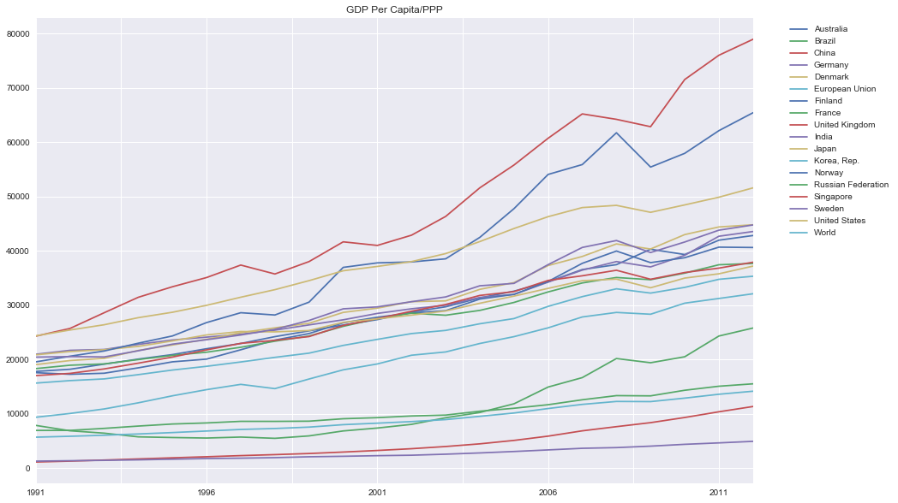

(Singapore is the topmost red line)

Fig. 0.1b: Box plot of selected countries and regions (World, EU) of GDP per capita/PPP from 1991 to 2012

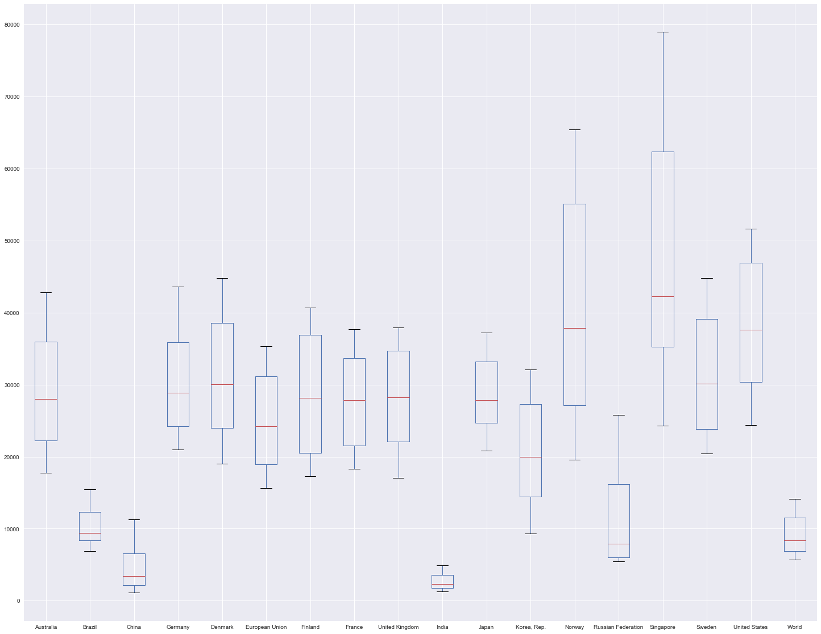

Fig. 0.2a: Line chart of selected countries and regions (World, EU) of life expectancy/years from 1991 to 2012

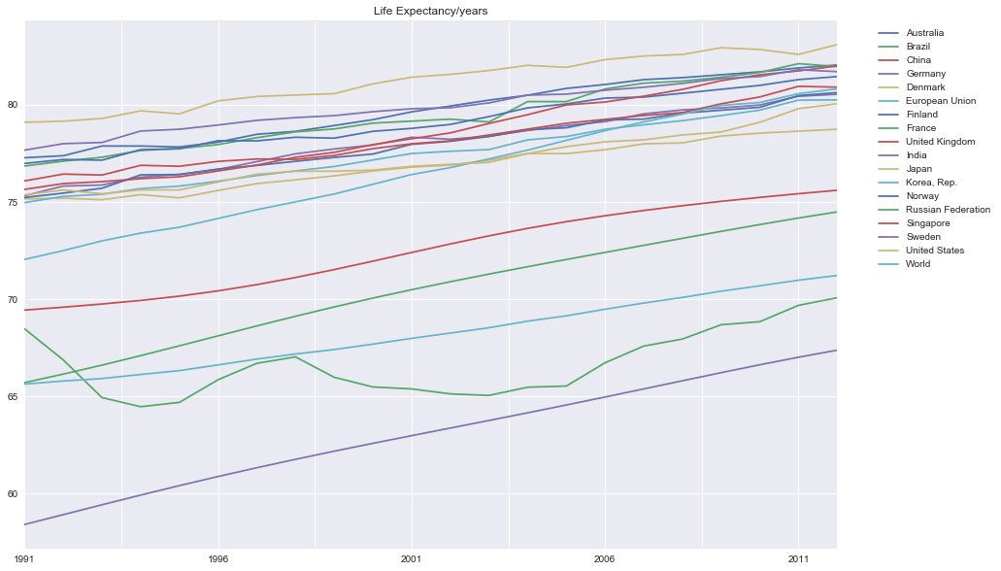

(Singapore is the topmost red line at 2012)

Fig. 0.2b: Box plot of selected countries and regions (World, EU) of life expectancy/years from 1991 to 2012

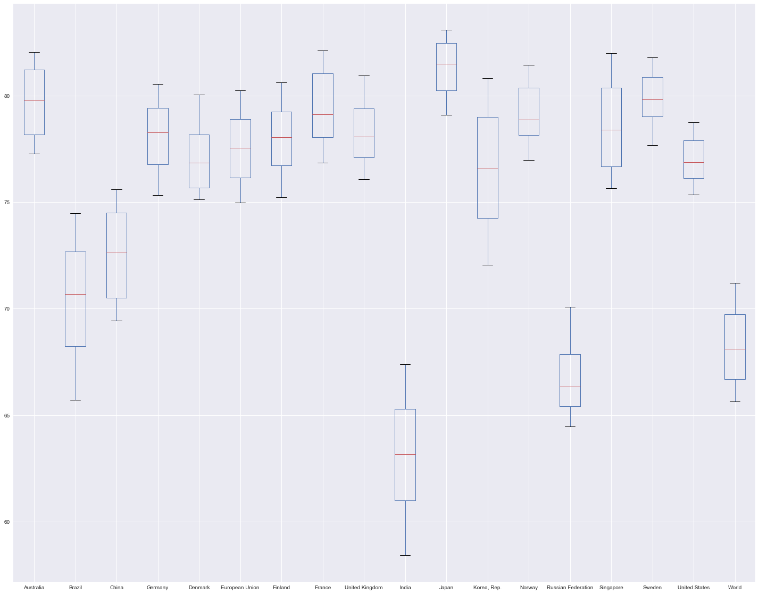

Fig. 0.3a: Line chart of selected countries and regions (World, EU) of number of mobile phone subscriptions/100 people from 1991 to 2012

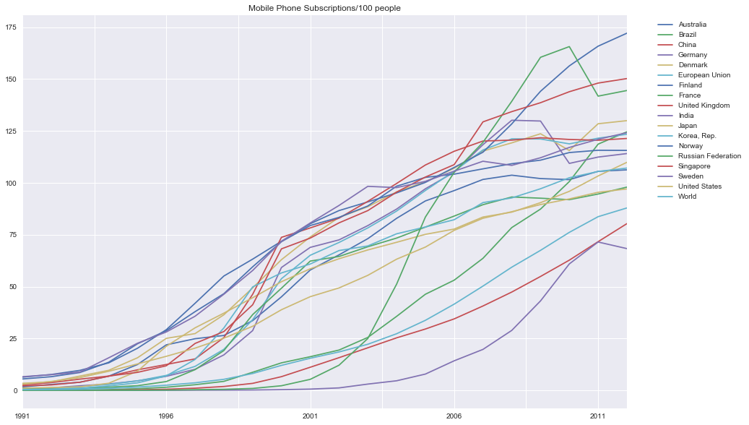

(Singapore is the topmost red line at 2012)

Fig. 0.3b: Box plot of selected countries and regions (World, EU) of number of mobile phone subscriptions/100 people from 1991 to 2012

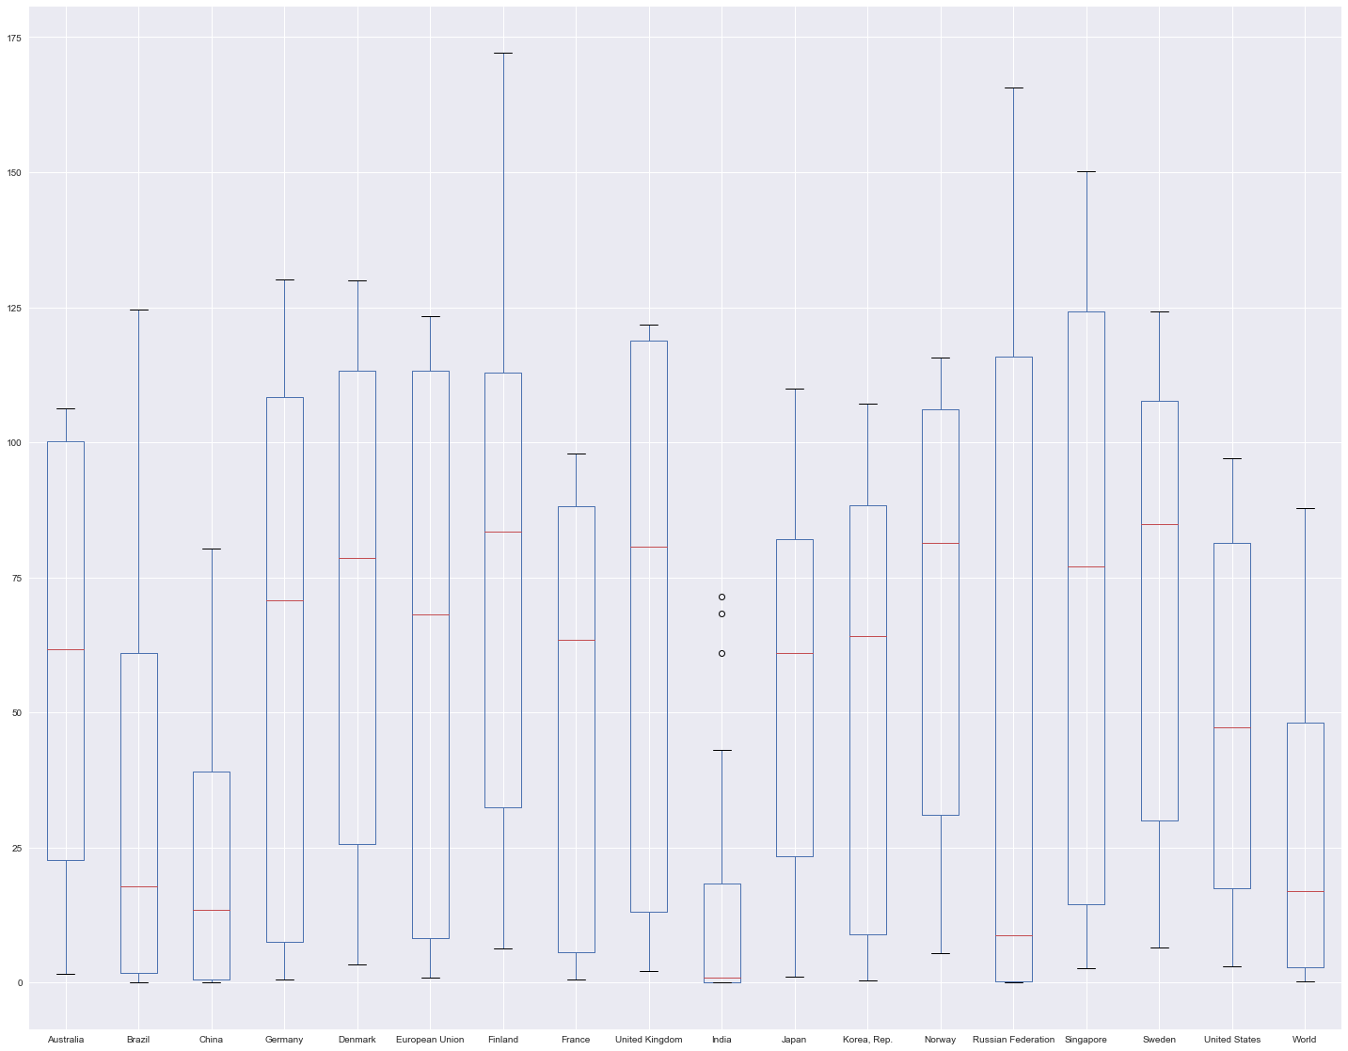

Fig. 0.4a Box plot of GDP per capita/PPP by year (1991-2012) for selected countries and regions (World, EU)

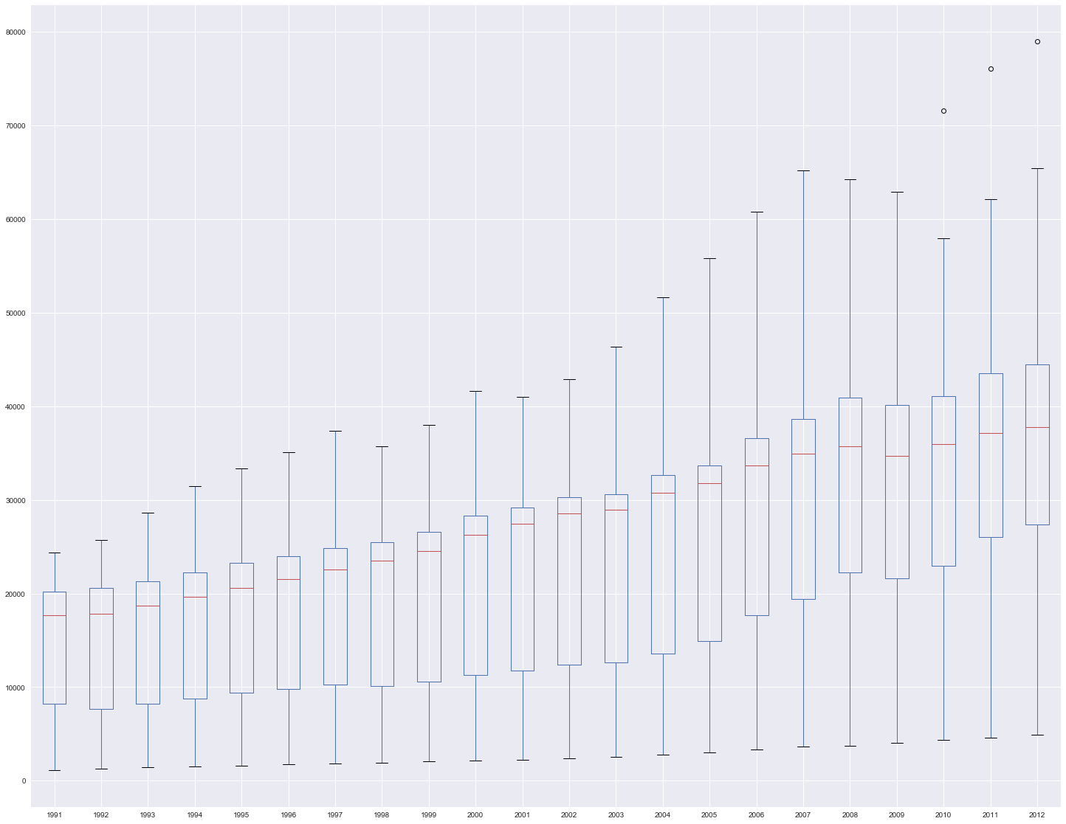

Fig. 0.4b: Box plot of life expectancy/years by year (1991-2012) for selected countries and regions (World, EU)

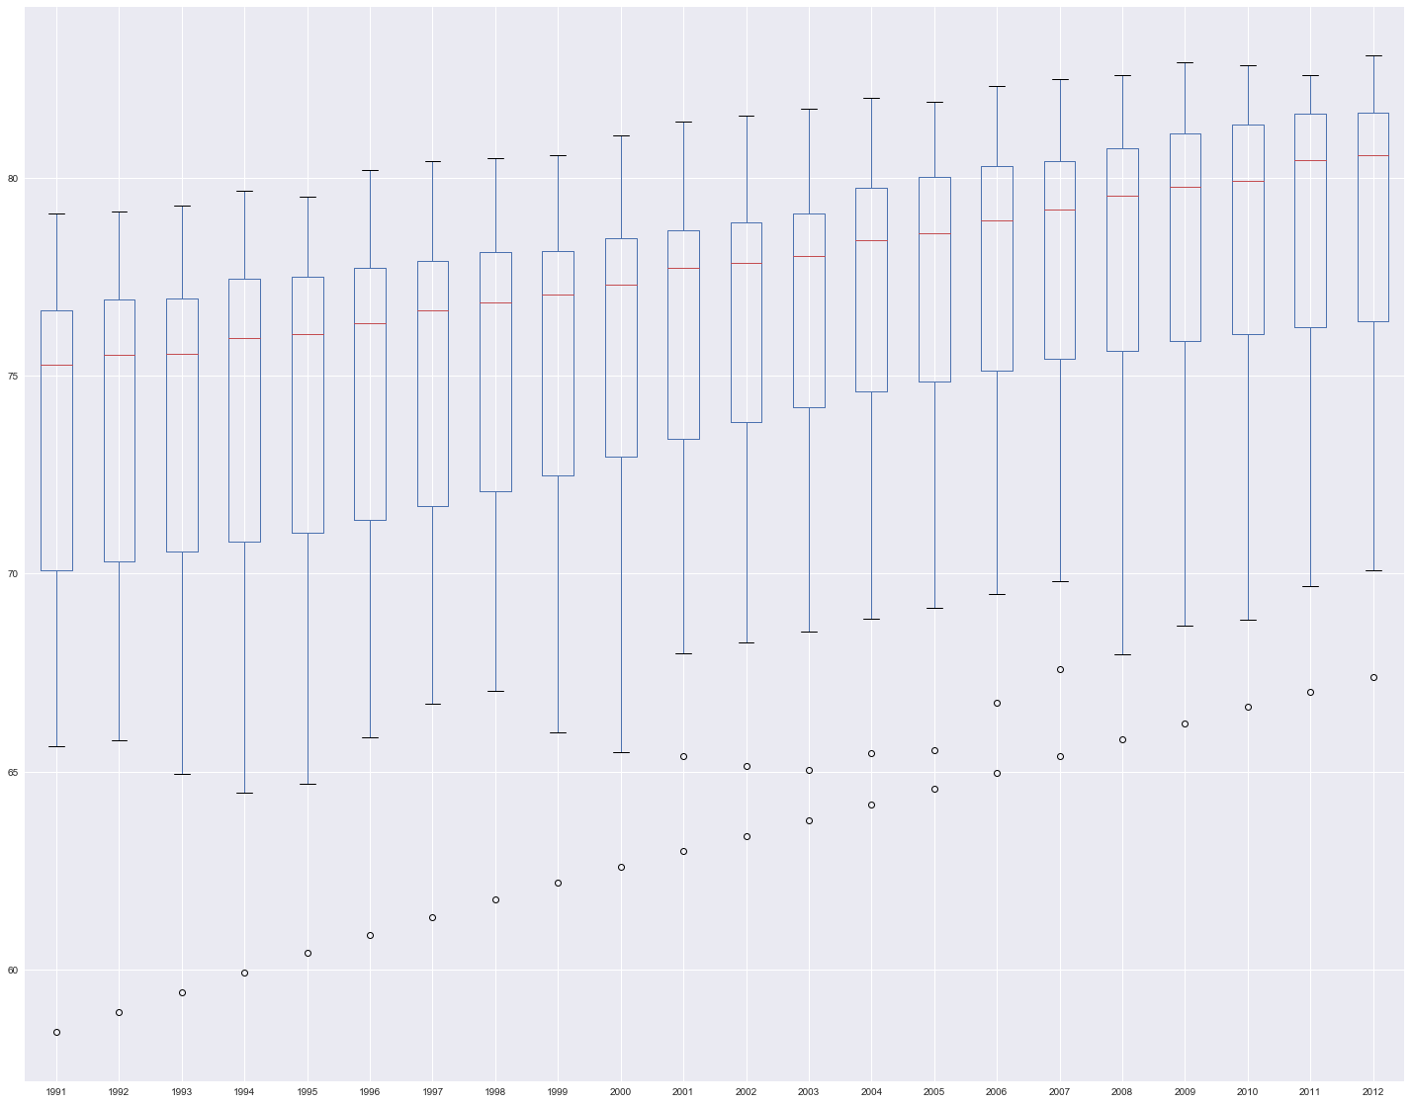

Fig. 0.4c: Box plot of number of mobile phone subscriptions/100 people by year (1991-2012) for selected countries and regions (World, EU)

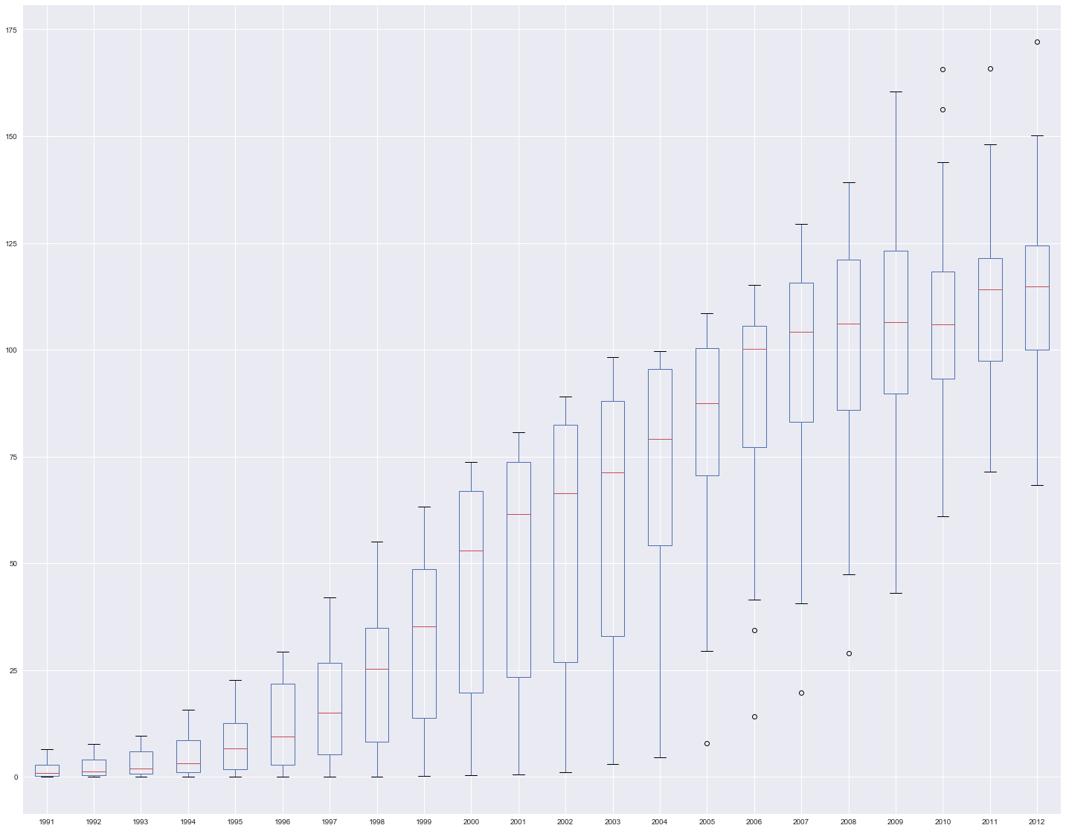

Fig. 1.3a: Linear correlation between sustainability and developmental indicators with expected values, Denmark

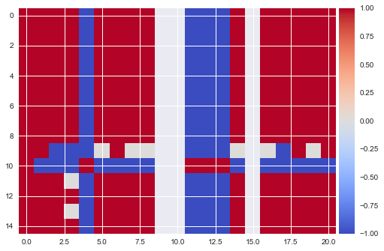

Fig. 1.3b: Spearman correlation between sustainability and developmental indicators with expected values, Denmark

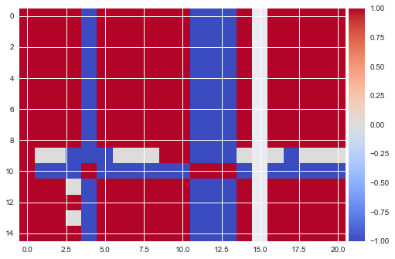

Fig. 1.4a: Linear correlation between sustainability and developmental indicators with expected values, Sweden

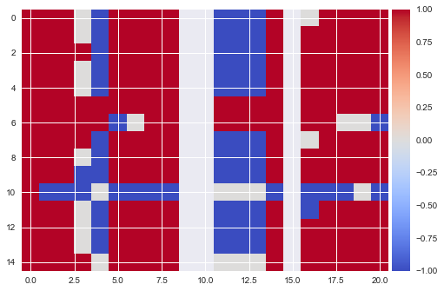

Fig. 1.4b: Spearman correlation between sustainability and developmental indicators with expected values, Sweden

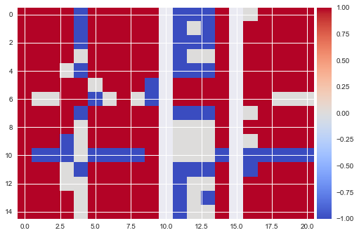

Fig. 1.5a: Linear correlation between sustainability and developmental indicators with expected values, China

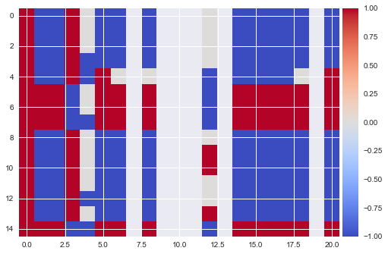

Fig. 1.5b: Spearman correlation between sustainability and developmental indicators with expected values, China

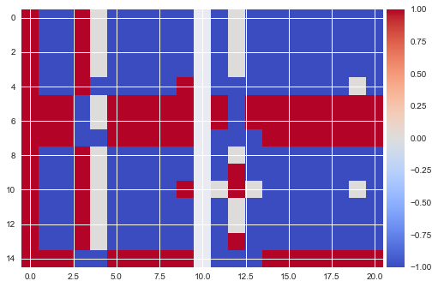

Fig. 1.6a: Linear correlation between sustainability and developmental indicators with expected values, India

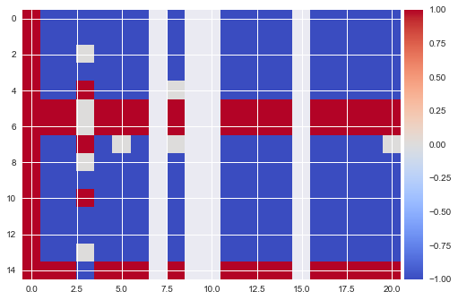

Fig. 1.6b: Spearman correlation between sustainability and developmental indicators with expected values, India

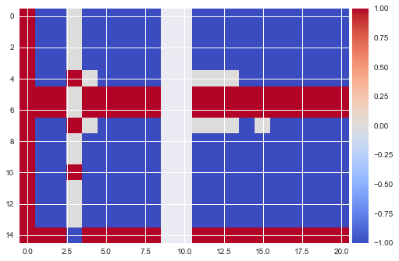

Fig. 2.1: Forest area in China, % (green), Rate of change of forest area (blue), y=0 (red)

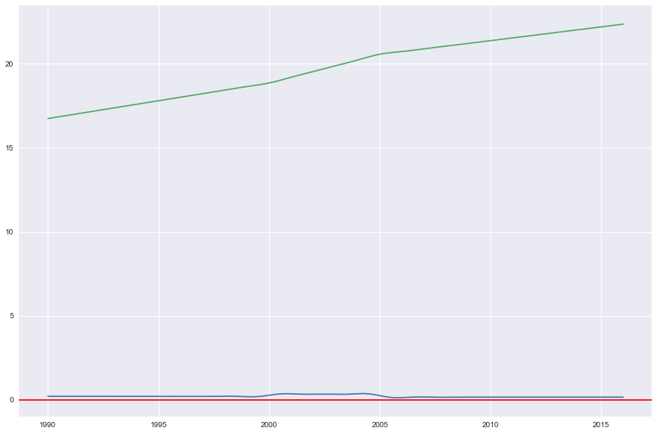

Fig. 2.2: Forest area in China, km2 (green), Rate of change in forest area (blue), y=0 (red)

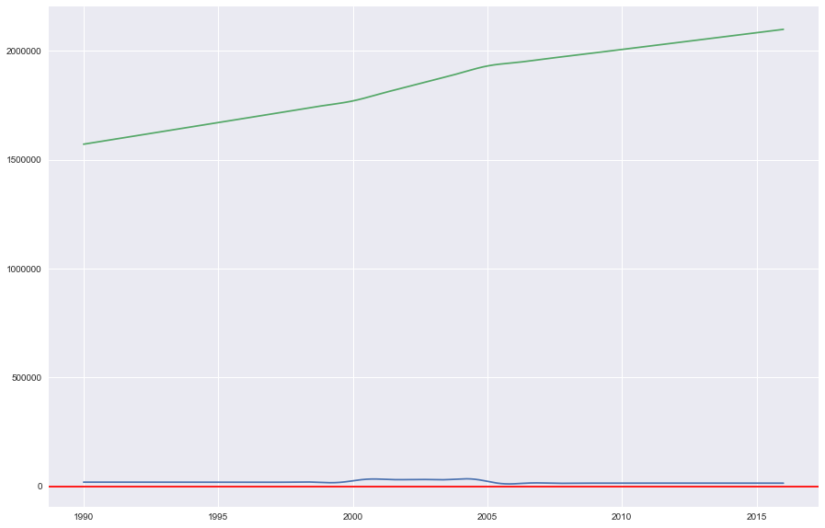

Fig. 3.1: Oil consumption per capita for various countries

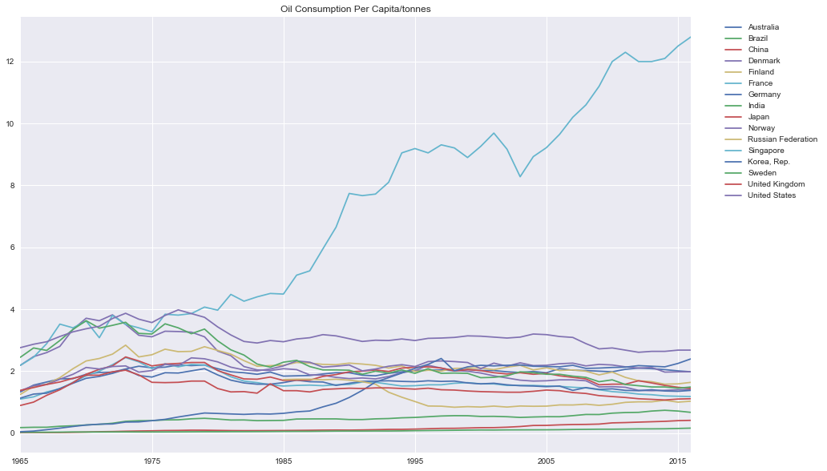

Fig. 3.2: Oil consumption per capita in Denmark, tonnes (green), Rate of change of oil consumption per capita (blue), y=0 (red)

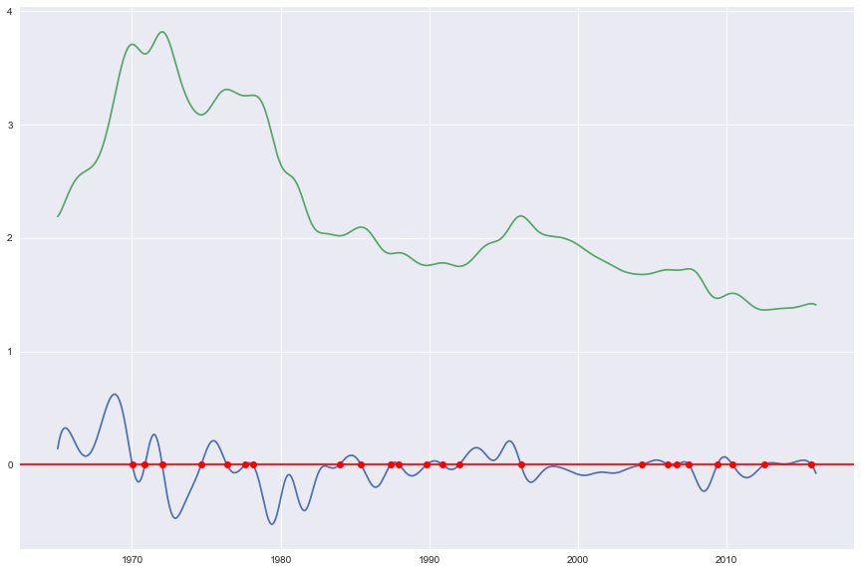

Fig. 3.3: Oil consumption per capita in Sweden, tonnes (green), Rate of change of oil consumption per capita (blue), y=0 (red)

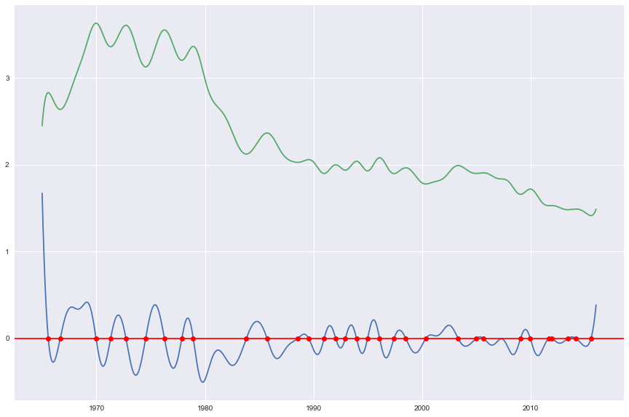

Fig. 4.1: Electrical consumption per capita, 2012-2014

| **Code** | **AUS** | **BRA** | **CHN** | **GER** | **DNK** | **FIN** | **FRA** | **GBR** | **IND** | **JPN** | **KOR** | **NOR** | **RUS** | **SGP** | **SWE** | **USA** |
| --- | --- | --- | --- | --- | --- | --- | --- | --- | --- | --- | --- | --- | --- | --- | --- | --- |
| **2012** | 10407.7 | 2501.5 | 3475.0 | 7270.2 | 6038.6 | 15689.2 | 7363.4 | 5449.3 | 723.2 | 7998.3 | 10305.3 | 24071.0 | 6617.1 | 8674.0 | 14289.6 | 12964.3 |
| **2013** | 10220.9 | 2568.8 | 3773.4 | 7217.5 | 6039.4 | 15510.8 | 7367.8 | 5409.6 | 764.2 | 7988.6 | 10384.6 | 23806.9 | 6539.2 | 8680.6 | 13870.4 | 13004.1 |
| **2014** | 10071.4 | 2620.0 | 3927.0 | 7035.5 | 5858.8 | 15250.0 | 6939.5 | 5129.5 | 804.5 | 7819.7 | 10496.5 | 22999.9 | 6602.7 | 8844.7 | 13480.1 | 12994.0 |

Fig.4.2: Electrical consumption per capita in Singapore, kWh (green), Rate of change in electrical consumption (blue), y=0 (red)

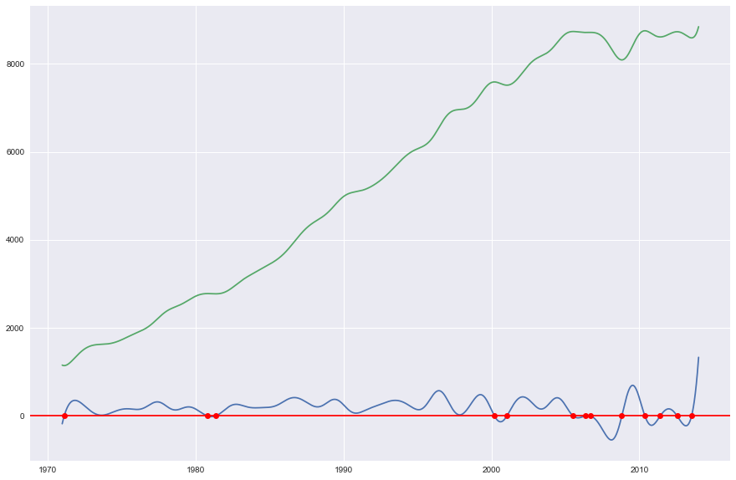

Fig. 4.3: Electrical consumption per capita in Denmark, kWh (green), Rate of change in electrical consumption (blue), y=0 (red)

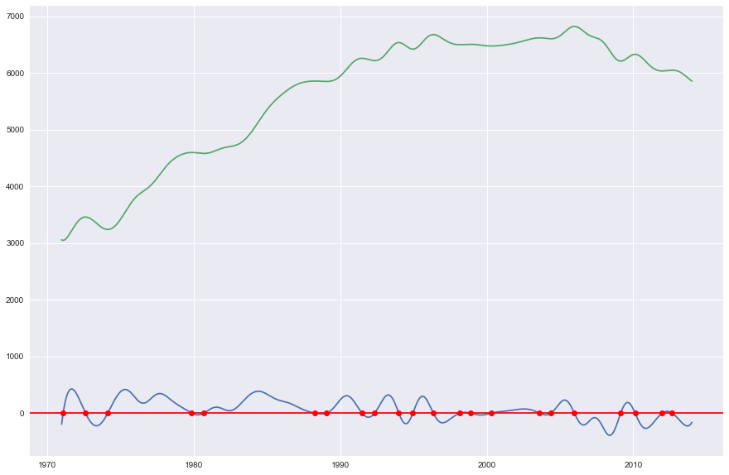

Fig. 4.4: Electrical consumption per capita in Sweden, kWh (green), Rate of change in electrical consumption (blue), y=0 (red)

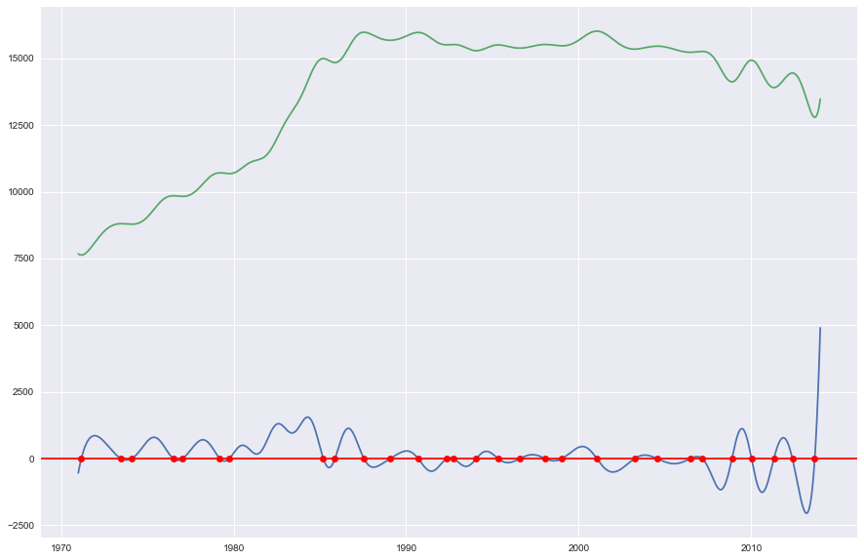

Fig. 5.1: GHG emissions from 1992 (reference point 0 on x-axis) to 2012 (blue), predicted BAU emissions from 2008 (red dotted), predicted emissions from 2012 onward (green); x-axis scale is 100:1 year

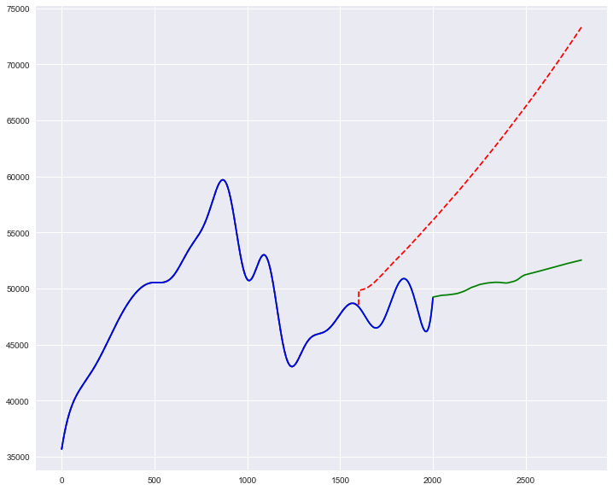

Fig. 5.2: GHG emission intensity from 1994 (reference point 0 on x-axis) to 2014 (blue), predicted GHG emission intensity from 2015 onwards (green), linear regression of predicted values from 2015 onward (green dotted); x-axis scale is 100:1 year

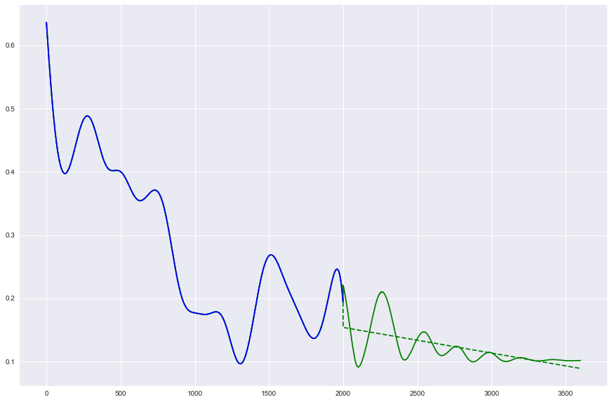

Fig. 6.1: Donut plot of total GHG emissions for Singapore by sector for 2007-2010

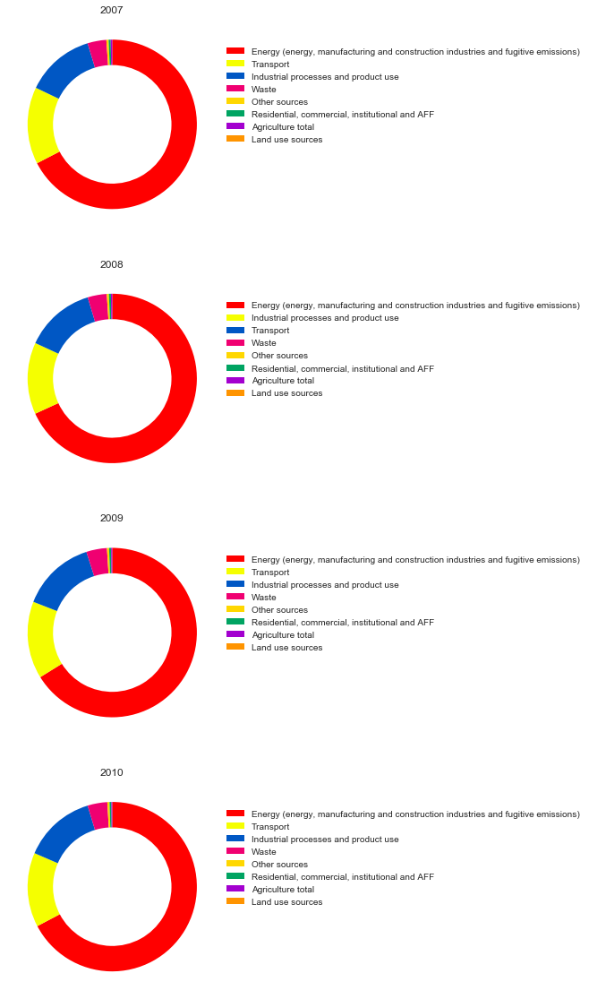

Fig. 6.2: Donut plot of total CO2 emissions for Singapore by sector for 2007-2010

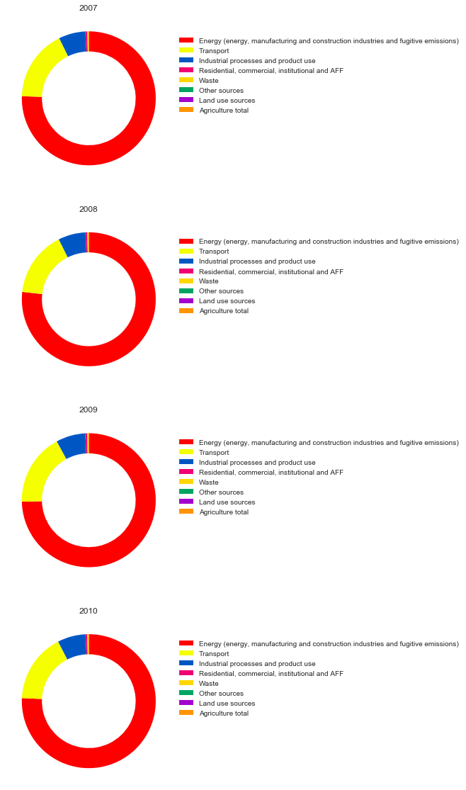

URLs used:

0: <https://data.worldbank.org/indicator/EN.ATM.CO2E.KT>

1: <https://data.worldbank.org/indicator/EN.ATM.CO2E.PC>

2: <https://data.worldbank.org/indicator/EN.ATM.GHGT.KT.CE>

3: <https://data.worldbank.org/indicator/SP.DYN.LE00.IN>

4: <https://data.worldbank.org/indicator/EG.FEC.RNEW.ZS>

5: <https://data.worldbank.org/indicator/EG.ELC.RNEW.ZS>

6: <https://data.worldbank.org/indicator/SP.DYN.IMRT.IN>

7: <https://data.worldbank.org/indicator/SL.UEM.TOTL.ZS>

8: <https://data.worldbank.org/indicator/NY.GDP.PCAP.KD.ZG>

9: <https://data.worldbank.org/indicator/NY.GDP.PCAP.CD>

10: <https://data.worldbank.org/indicator/NY.GDP.PCAP.PP.CD>

11: <https://data.worldbank.org/indicator/IT.NET.USER.ZS>

12: <https://data.worldbank.org/indicator/IT.CEL.SETS.P2>

13: <https://data.worldbank.org/indicator/SH.STA.SMSS.ZS>

14: <https://data.worldbank.org/indicator/SH.H2O.SMDW.ZS>

15: <https://data.worldbank.org/indicator/NY.GNP.PCAP.KD.ZG>

16: <https://data.worldbank.org/indicator/NY.GDP.MKTP.KD.ZG>

17: <https://data.worldbank.org/indicator/AG.LND.FRST.ZS>

18: <https://data.worldbank.org/indicator/AG.LND.FRST.K2>

19: <https://data.worldbank.org/indicator/NY.GNP.MKTP.KD.ZG>

20: <https://data.worldbank.org/indicator/EG.ELC.FOSL.ZS>

21: <https://data.worldbank.org/indicator/EG.USE.COMM.FO.ZS>

22: <https://data.worldbank.org/indicator/EG.USE.ELEC.KH.PC>

23: <https://ourworldindata.org/human-development-index>

24: <https://www.kaggle.com/akul27/average-temperature-per-country-per-year/data>

25: <https://data.worldbank.org/indicator/EG.ELC.ACCS.ZS>

26: <https://data.worldbank.org/indicator/EG.USE.PCAP.KG.OE>

27: <https://www.gapminder.org/data/>

28: <https://www.gapminder.org/data/>

29: <http://hdr.undp.org/sites/default/files/2018_all_indicators.xlsx>

30: <http://hdr.undp.org/sites/default/files/2018_all_indicators.xlsx>

31: <https://data.worldbank.org/indicator/NY.GNP.PCAP.PP.CD>

32: <https://data.worldbank.org/indicator/VC.IHR.PSRC.P5>

33: <https://data.worldbank.org/indicator/NY.GNP.PCAP.CD>

34: <https://data.worldbank.org/indicator/EN.ATM.CO2E.KD.GD>

35: <https://knoema.com/atlas/Singapore/CO2-emissions>

36: <https://knoema.com/atlas/Singapore/topics/Environment/Emissions/Methane-emissions>

37: <https://knoema.com/atlas/Singapore/topics/Environment/Emissions/Nitrous-oxide-emissions>

38: <http://www.fao.org/faostat/en/#data/EM>

List of required python modules:

numpy, pandas, h5py, keras, tensorflow, scipy, sklearn